Overview - Technology

Roughly, ThorCon’s molten salt reactor design concept involves the main components being sealed in a “can”. Inside every “can” there is a 550 MWt reactor (scale of the MSRE reactor) along with the primary loop heat exchanger (PHX) and a primary loop pump (PLP). The pump takes the liquid fuel salt from the reactor and pushes it to the PHX. The fuelsalt then travels downwards the PHX where it transfers heat to a secondary salt. After this, the fuel salt again flows through the reactor core which is mostly filled with graphite slabs (moderator) and a portion of the uranium fissions as it rises through the reactor core. In the process, a portion of the thorium is turned into fissile uranium (breeding). The secondary salt loop (green) carries a mixture of sodium fluoride and beryllium fluoride. Hot secondary salt is pumped out of the top of the PHX to a secondary heat exchanger where it transfers the heat to a mixture of sodium nitrate and potassium nitrate commonly called solar salt (purple). This solar salt transfers its heat to a steam loop creating supercritical steam and reheats the steam to increase the plants efficiency Figure 1.

|  |  |  |  |  |
| --- | --- | --- | --- | --- |
| **Electrical Output (MW)** | 250 |  | **Net U fissile consumed (kg/y)** | 112 |
| **Thermal Output (MW)** | 557 |  | **Plant efficiency (%)** | 44.9 |
| **Fuelsalt** | NaF-BeF-ThF4-UF4 |  | **Percent Thorium fuel (%)** | 25.1 |
| **Mol Percent** | 76/12/9.8/2.2 |  | **Can OD (m)** | 7.259 |
| **Fuelsalt flow rate (kg/s)** | 2934 |  | **Can Height (m)** | 11.738 |
| **Reactor Temperature in ©** | 564 |  | **Reactor OD (m)** | 4.961 |
| **Reactor Temperature out ©** | 704 |  | **Reactor Height (m)** | 5.717 |
| **Loop transit time (s)** | 13.8 |  | **Can Weight (no salt) (kg)** | 381,767 |
| **Reactor inlet pressure (bar g)** | 1006 |  | **Fuelsalt Weight (kg)** | 40473 |

In dealing with the thermal expansion the reactor and the PHX are hang from the “can” lid by cables allowing the can to expand independently from the PLP. The cables also allow the reactor and the PHX to be pushed apart as the primary loop heats up. The cables do not only allow the PHX to move laterally but also to tilt and rotate (Hammock Suspension System). Directly below the Can is the fuelsalt drain tank (FDT). In the bottom of the can there is a fuse valve (freeze plug) which is merely a low point in a drain line. If the reactor heats up for any reason, the plug will thaw, and the fuel salt will drain to the FDT. The drain is totally passive. Because of the reactor size we expect moderately high-power density of about 16 MW per cubic meter of active core. This involves changing the core graphite every four years and therefore the cans are arranged in pairs to make up a power module. Before shutting down, the first can will transfer the fuel salt to the new can (which is in standby or cool down mode) while the old one undergoes maintenance meaning there is no stopping or interruption of power.

If we were to take a 1GWe ThorCon, which would be made up of two 500 MWe silo halls with all the respective components, the plant could fit easily on a 25-acre site (Figure 2). Since the plant is underground there is plenty of room on the site surface to place other type of renewable technologies like solar or wind depending on the geographical conditions.

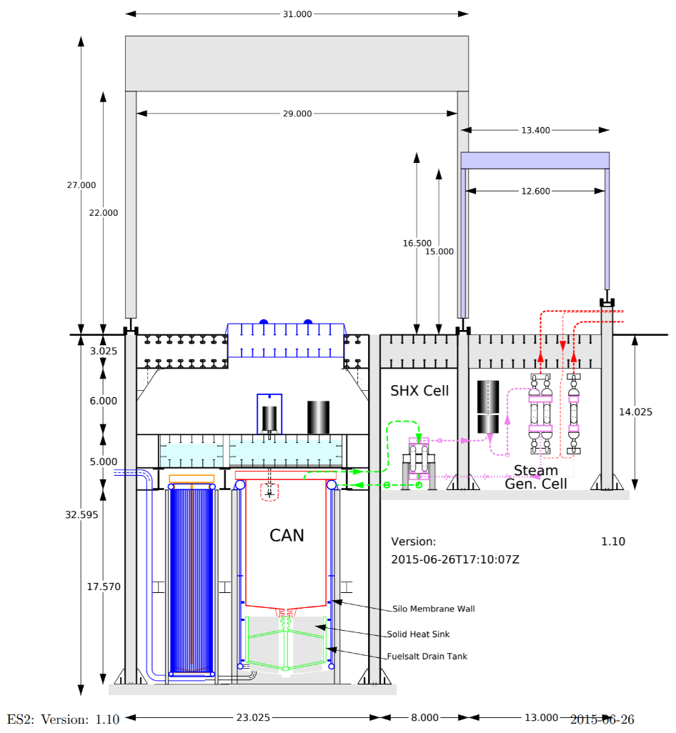

Figure - Silo Hall Cross-section

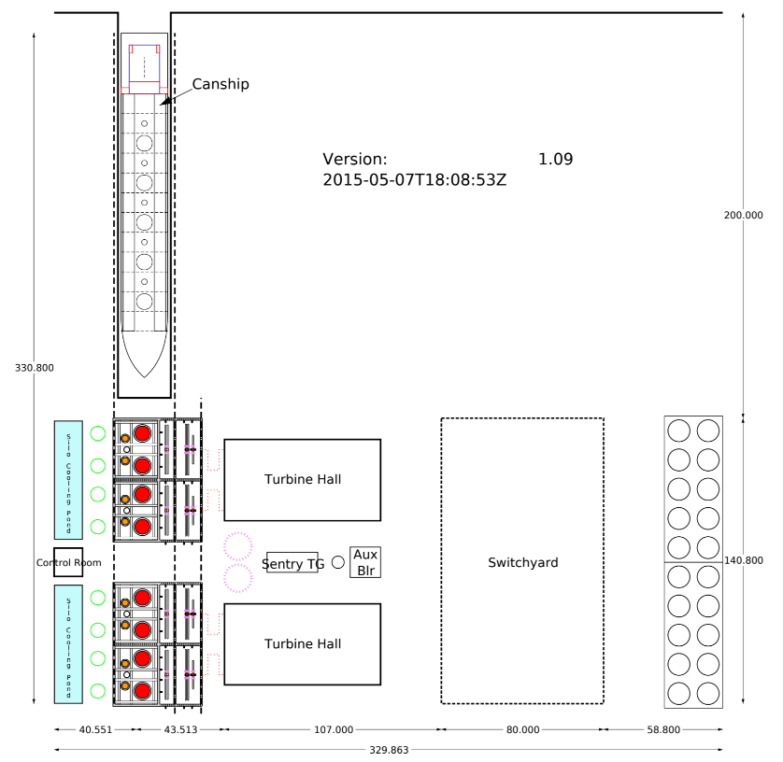

Figure - Site Plan

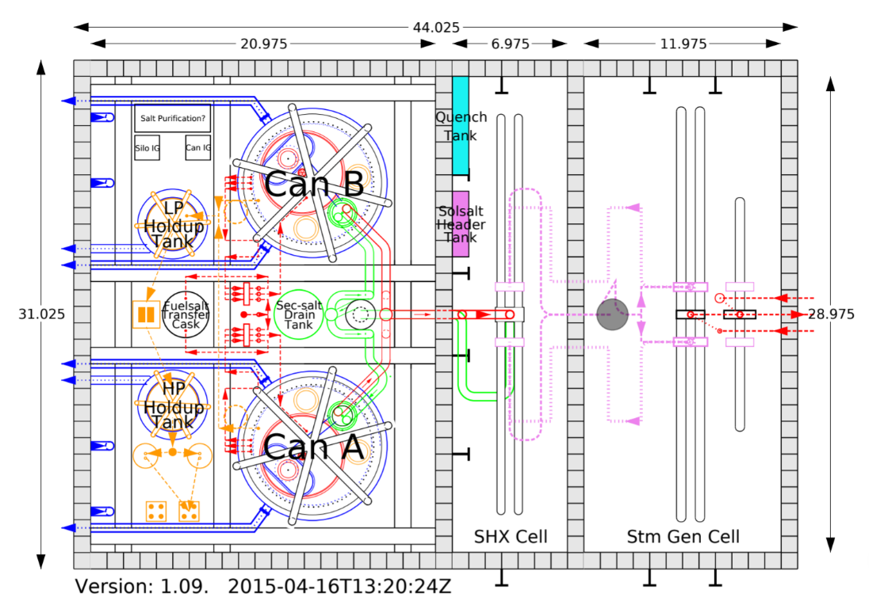

Figure - Plan view of power module